Diagonal (Oblique) Orientation

Definition
# Source: AI Source: Provided by: [Data Path: Persons Table -> ID Column: 1, Name_En Column: Motasem Essam] -> From: [ChatGPT] on [7/20/2026]
Diagonal Orientation, also called Oblique Orientation, is the arrangement of an object so that it is inclined at an angle relative to both the horizontal and vertical reference axes. The object is neither perfectly horizontal nor perfectly vertical.
Diagonal orientation is commonly used to describe slanted or inclined objects in geometry, engineering, architecture, surveying, technical drawing, and computer graphics.

Characteristics
# Source: AI Source: Provided by: [Data Path: Persons Table -> ID Column: 1, Name_En Column: Motasem Essam] -> From: [ChatGPT] on [7/20/2026]
A diagonally (obliquely) oriented object:
- Is inclined relative to the horizontal axis.
- Is inclined relative to the vertical axis.
- Forms an angle that is not:
  - $0^{∘}$
  - ${90}^{∘}$
  - ${180}^{∘}$
  - ${270}^{∘}$
- Represents a slanted or angled alignment.
- Can have positive or negative inclination depending on the direction.

Illustration
# Source: AI Source: Provided by: [Data Path: Persons Table -> ID Column: 1, Name_En Column: Motasem Essam] -> From: [ChatGPT] on [7/20/2026]

╱
╱
╱
╱
Or

╲
╲
╲
╲

Orientation Angle
# Source: AI Source: Provided by: [Data Path: Persons Table -> ID Column: 1, Name_En Column: Motasem Essam] -> From: [ChatGPT] on [7/20/2026]
The orientation is measured relative to the positive horizontal axis.
Examples:
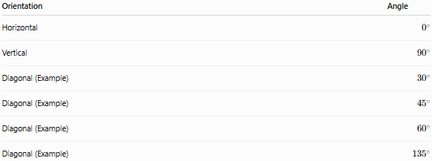
Orientation | Angle
Horizontal | $$0^{∘}$$
Vertical | $${90}^{∘}$$
Diagonal (Example) | $${30}^{∘}$$
Diagonal (Example) | $${45}^{∘}$$
Diagonal (Example) | $${60}^{∘}$$
Diagonal (Example) | $${135}^{∘}$$
Any angle that is not purely horizontal or vertical represents an oblique orientation.

Examples
# Source: AI Source: Provided by: [Data Path: Persons Table -> ID Column: 1, Name_En Column: Motasem Essam] -> From: [ChatGPT] on [7/20/2026]
Diagonal orientation can be observed in:
- A staircase
- A roof slope
- A ladder leaning against a wall
- A bridge support beam
- A diagonal road on a map
- An inclined conveyor belt
- A slash symbol (/ or )

Measurement
# Source: AI Source: Provided by: [Data Path: Persons Table -> ID Column: 1, Name_En Column: Motasem Essam] -> From: [ChatGPT] on [7/20/2026]
Diagonal orientation is commonly described using:
- Orientation angle (degrees or radians)
- Slope
- Inclination
For a line:
$$m=tan⁡\left(θ\right)$$
where:
- $m$= slope
- $θ$= angle with the horizontal axis

Applications
# Source: AI Source: Provided by: [Data Path: Persons Table -> ID Column: 1, Name_En Column: Motasem Essam] -> From: [ChatGPT] on [7/20/2026]
Diagonal orientation is used in:
- Geometry
- Architecture
- Structural engineering
- Civil engineering
- Mechanical design
- CAD (Computer-Aided Design)
- Computer graphics
- Surveying
- Robotics
- Manufacturing

Advantages
# Source: AI Source: Provided by: [Data Path: Persons Table -> ID Column: 1, Name_En Column: Motasem Essam] -> From: [ChatGPT] on [7/20/2026]
Diagonal orientation:
- Represents inclined structures naturally.
- Supports engineering and architectural design.
- Enables slope and inclination calculations.
- Improves structural stability analysis.
- Describes movement and direction accurately.

Limitations
# Source: AI Source: Provided by: [Data Path: Persons Table -> ID Column: 1, Name_En Column: Motasem Essam] -> From: [ChatGPT] on [7/20/2026]
Diagonal orientation:
- Depends on the chosen reference frame.
- May require angle measurements for precise description.
- Can appear different if the coordinate system is rotated.

Comparison with Other Orientations
# Source: AI Source: Provided by: [Data Path: Persons Table -> ID Column: 1, Name_En Column: Motasem Essam] -> From: [ChatGPT] on [7/20/2026]
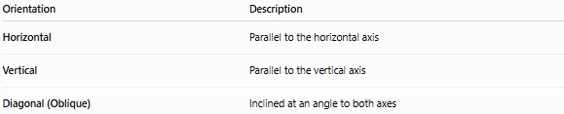
Orientation | Description
Horizontal | Parallel to the horizontal axis
Vertical | Parallel to the vertical axis
Diagonal (Oblique) | Inclined at an angle to both axes

Key Points
# Source: AI Source: Provided by: [Data Path: Persons Table -> ID Column: 1, Name_En Column: Motasem Essam] -> From: [ChatGPT] on [7/20/2026]
- Diagonal (Oblique) Orientation means an object is aligned at an angle.
- It is neither horizontal nor vertical.
- The orientation is commonly described by its inclination angle.
- It is widely used in geometry, engineering, architecture, surveying, CAD, and technical drawing.

Conclusion
# Source: AI Source: Provided by: [Data Path: Persons Table -> ID Column: 1, Name_En Column: Motasem Essam] -> From: [ChatGPT] on [7/20/2026]
Diagonal (Oblique) Orientation describes the alignment of an object that is inclined relative to both the horizontal and vertical reference axes. It is characterized by an orientation angle other than the principal horizontal or vertical directions and is fundamental for representing sloped or inclined structures. Diagonal orientation plays an important role in geometry, engineering, architecture, surveying, construction, computer graphics, and technical drawing, where accurate representation of angled objects is essential for design, measurement, and analysis.

